Exercise 1: Setting Up JUnit

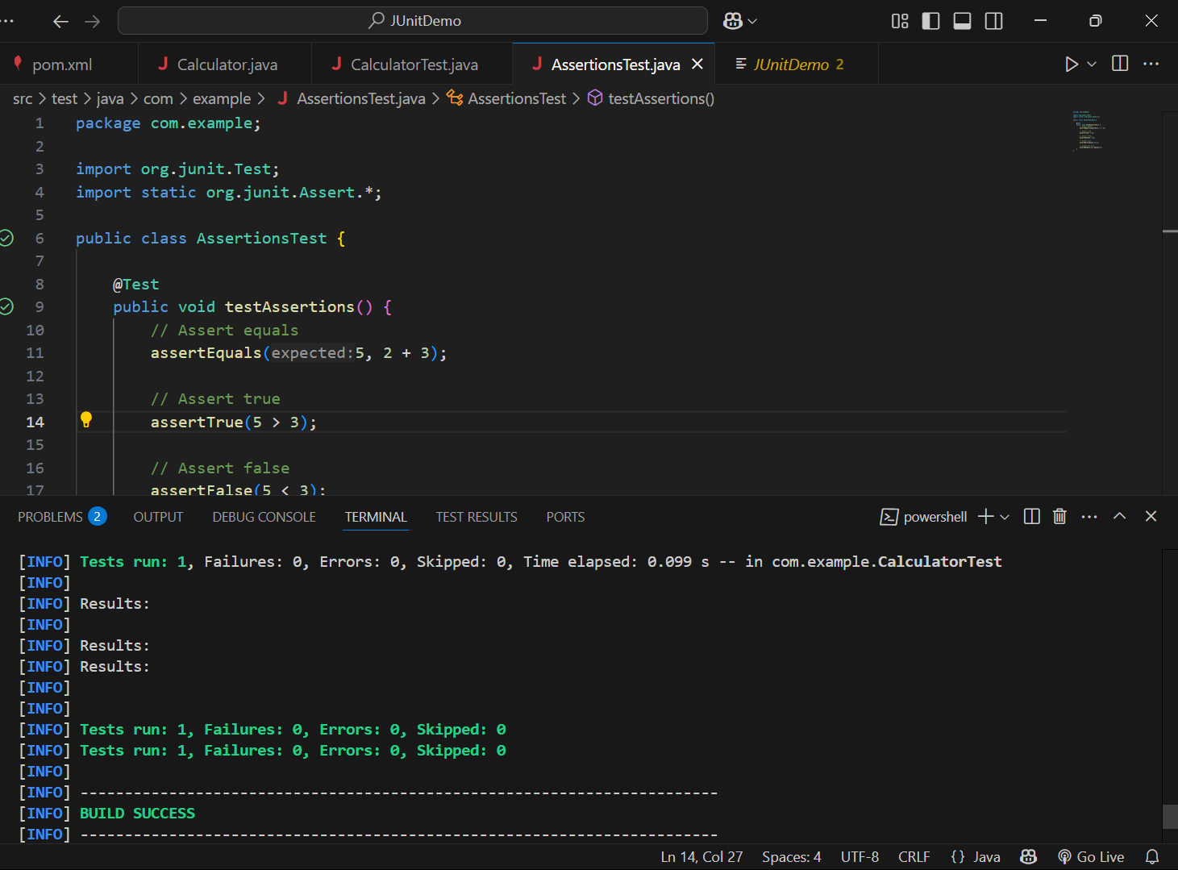

Exercise 2: Assertions in JUnit

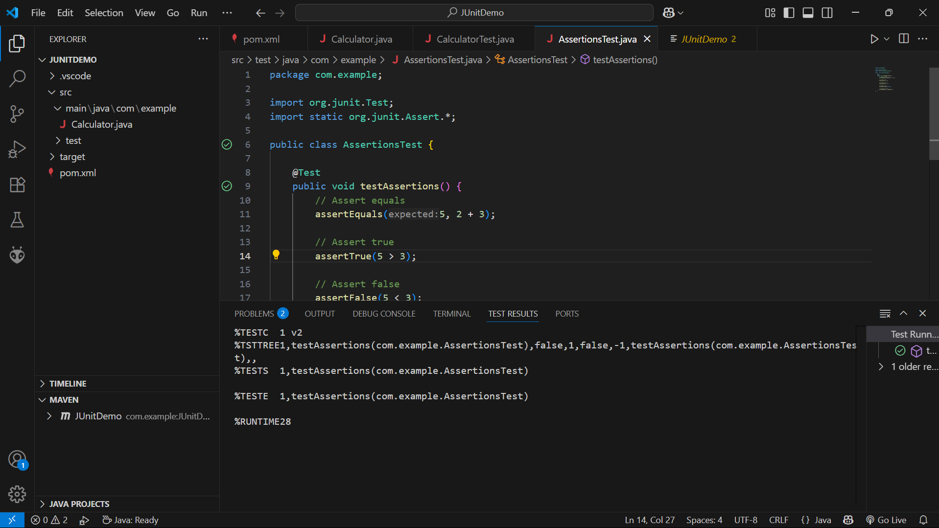

Exercise 3: Arrange-Act-Assert (AAA) Pattern, Test Fixtures, Setup and

Teardown Methods in JUnit

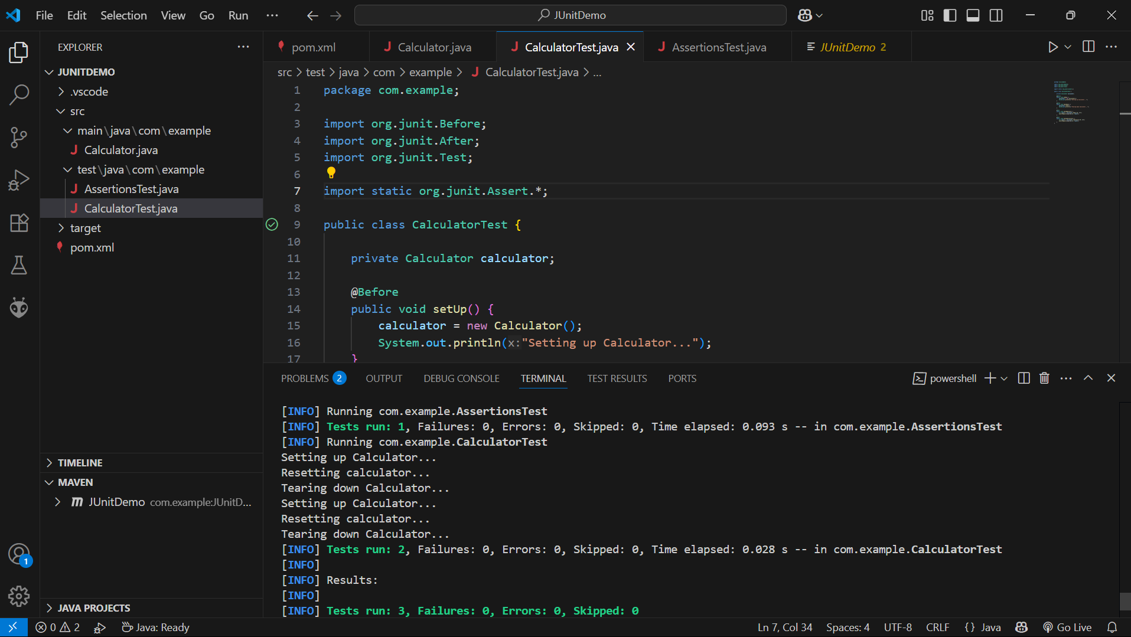

Exercise 1: Mocking and Stubbing

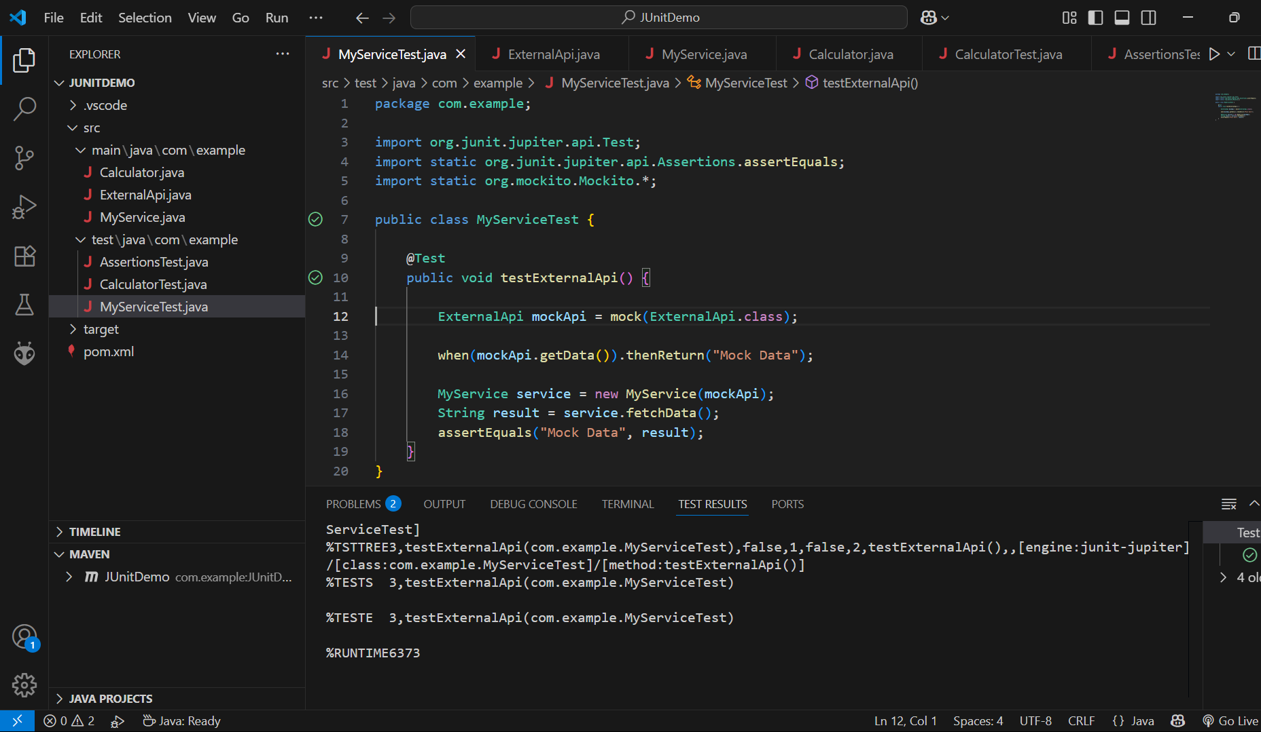

Exercise 2: Verifying Interactions

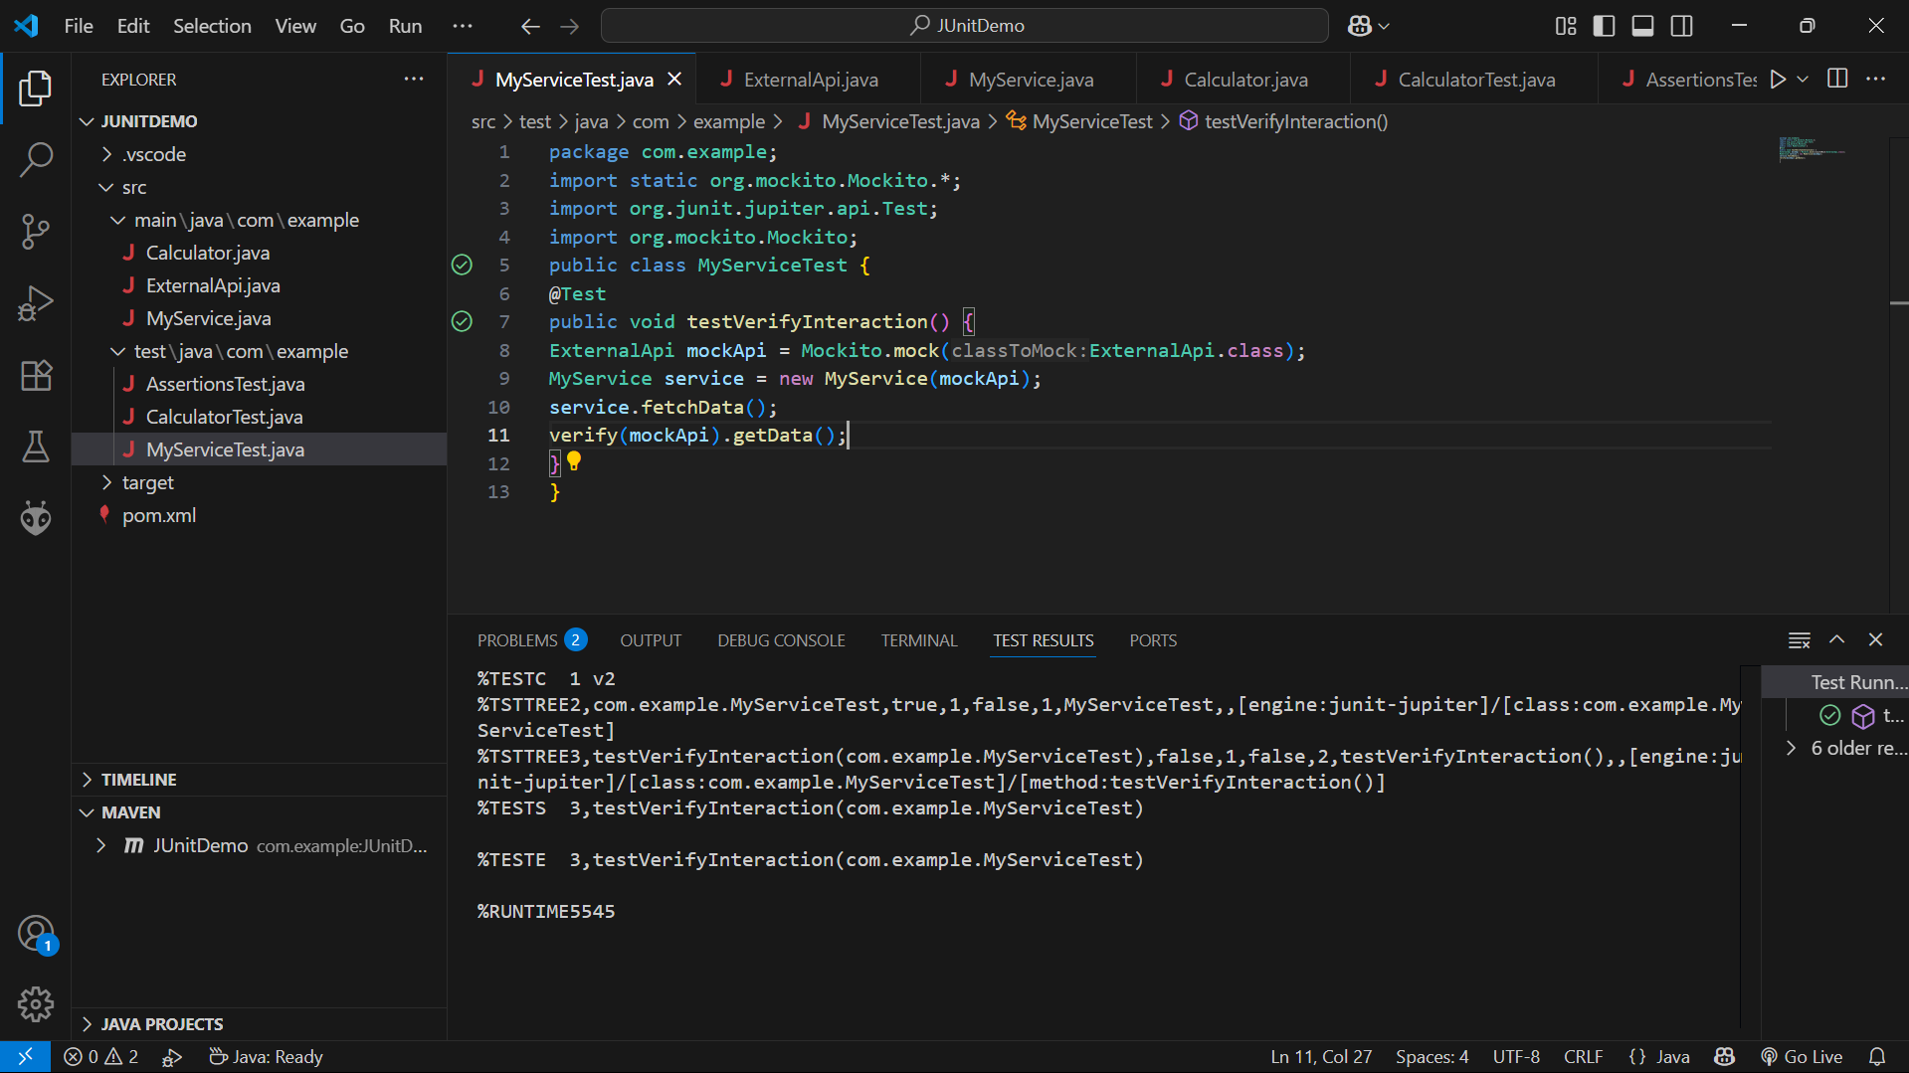

Logging using SLF4J

Exercise 1: Logging Error Messages and Warning Levels

